**Love in Action! PPUMC Pledge Drive**

**Frequently Asked Questions**

**Why should I give?**

We give because there is need. No matter our status in life, there are those who have less than us. Jesus calls us to care for those in need; to not just pray for those in need but to take action.

We give because we support the work of PPUMC. The work of the church has so many parts:  worship, Christian education, sharing our buildings with the community, supporting both our members and the wider community, supporting peace and justice causes and much more too!

PPUMC depends on your donations to pay our staff, to maintain our building, and to pay for our programs.

**Why should I pledge?**

In order to be planful and to make commitments, the PPUMC Administrative Council needs to know that we can fund the work of the church. If we know how much money we can count on receiving during the year, we can budget and plan much better.

When you make a promise, it is much easier to carry through on it. If you only have a vague commitment to give each week, it’s easy to forget or to spend your offering money on other things.

A pledge helps PPUMC know what money they will have for the year and should help you budget and follow through with your commitment.

**What if my finances change during the year and I can’t give what I pledged?**

The church knows that life can throw everyone a curve ball that wreaks havoc in the personal budget. The church counts on your pledge in order to stay within their budget, but the church is your family and will understand and support you even if your finances change.

**How much should I give?**

Every person must come up with an amount with which they are comfortable.  Some people “tithe” or give a tenth of their income; others give closer to 2 or 3%.  Some people think in terms of their yearly income; others look at their net monthly income and give a percentage of that; others think in terms of a weekly amount.  PPUMC asks people to consider giving 3 - 5% of your income. The important thing is to give from a position of joy and generosity. Be happy that you have enough to share!

This chart can help you calculate your giving as a percentage of your income. Find your annual income on the left column, then find your monthly gift to the right. What percentage of your income is your monthly pledge?

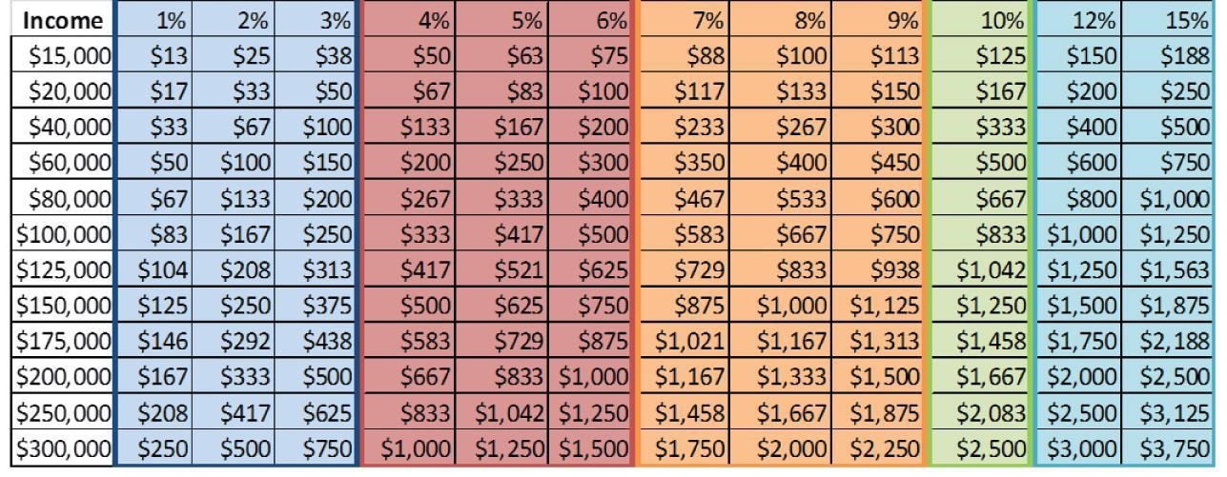

If you have given at a certain level in the past, consider a possible increase in giving. Any amount of increase is helpful. Some sample calculations on increases in giving:

If your annual income is $40,000, then a **1%** increase in your giving is:

* Around $7.50 per week
* $33 per month

If your annual income is $100,000 then a **5%** increase in your giving is:

* $77 per week
* $333 per month

Each person and each family has a unique set of circumstances that impact their capacity for giving. If you find yourself in a season of abundance, **we encourage you to consider a meaningful increase of your pledge**. If you circumstances are currently challenging, we understand the need to step back. **All gifts are needed and valuable, no matter the size!**

**Can I give by automatic bank account withdrawal?**

Yes! It’s a great idea to use automatic payments so that you give even when you can’t physically be present in worship. Giving becomes as automatic as paying your rent or utility bill.  What a great thing it is to be generous without needing to even think about it!  
  
**Is my pledge kept confidential?**

Yes. Only a very few financial leaders of the church know the specific amounts that people contribute and these leaders are pledged to maintain confidentiality.  Judy Bratt our financial secretary is one of the few people who know how much you pledge. You can send your pledge card directly to Judy.

**What does the church's budget support?**

Our budget is tailored to carry out the work and mission of our church.

Our primary budget area is our staff:  Our pastor is ¾ time. Pastor Paul Baudhuin is our pastor, a resident theologian and preacher, he oversees the staff and administrates the various operations and programs of the congregation, provides spiritual leadership, and facilitates both ordinary and special occasion worship services. We employ a small part time staff who provide quality office work, care, and the musical excellence we deeply value: an Administrative Assistant in the office, a Communications Associate, a childcare provider, a Director of Music.

We have two other primary budget areas. First, is the upkeep and improvement of our historic church building. The church building itself serves not only to house our own worship, programs, and projects, but also as a gathering place for many neighborhood organizations and art groups.

The final primary budget area is social justice ministries. Even before we take up offerings at special events like monthly concerts and the like, we support people in need through donations to the larger United Methodist church and to local mission projects. We provide a free monthly community meal, and stock small food pantries. We provide quarterly children’s programming.

**Can I pay my pledge early or in one lump sum?**

It’s helpful for the church to have money coming in throughout the year. If everyone waited until December 30th to pay their pledge, we would be in financial trouble. Some people pay their pledge early with lump sums from their retirement minimum distributions; some people have windfalls during the year and use that money to pay their pledge early; some people wait until the end of December to give their full amount; most people give on a weekly or monthly basis. We ask that you give in whatever amount and in whatever way works best for you.